MyTAXI SYSTEM
GUI Specifications
Version 0.1

Revision History
Date | Version | Summary of Change | Author
<dd/Mmm/yyyy> | <x.y> | <Section> - <Change> | <First Name + Last Name>
14 June 2016 | 0.1 | Initial version | Team01

Distribution for Review/Approval
Name | Title & Company | Issue Version | Issue Date | Review Date | Approval Date
Doan Vo | BA Lead - BAC | 0.1 | 14 June 2016 | 14 June 2016

Contents
1 Introduction 4
1.1 Purpose 4
1.2 Scope 4
1.3 References 4
2 Screen List 4
3 Screen Flow 4
4 Screen Details 4
4.1 Screen <Screen ID – Name> 5
4.1.1 Layout 5
4.1.2 GUI Elements 5

Introduction

Purpose
This document is the Graphical Interface Design Document for the MyTaxi system. The purpose of this document is to present the design approach for the graphical interface of the MyTaxi system.

Scope
The primary intended audience of this document are system designers and system developers. The document intents to provide the members of the MyTaxi project a unified view of the technical details of the system design to be followed during the development of the respective application. The document may need to be updated later to incorporate possible changes during development

References
Applicable references are:
1/ Vision_v0.1
2/ Glossary_v0.1
3/ Use Case Model_v0.1
4/ Supplementary Specifications_v0.1
5/ Use Case_v0.1

Screen List
Below is the list of screens and their associated use cases.

No | Screen ID | Screen Description | Associated UCs | Notes
 | SC001 | Start Screen | UC01
 | SC002 | Choose how to register | UC02
 | SC003 | Driver Register Screen | UC03

Screen Flow
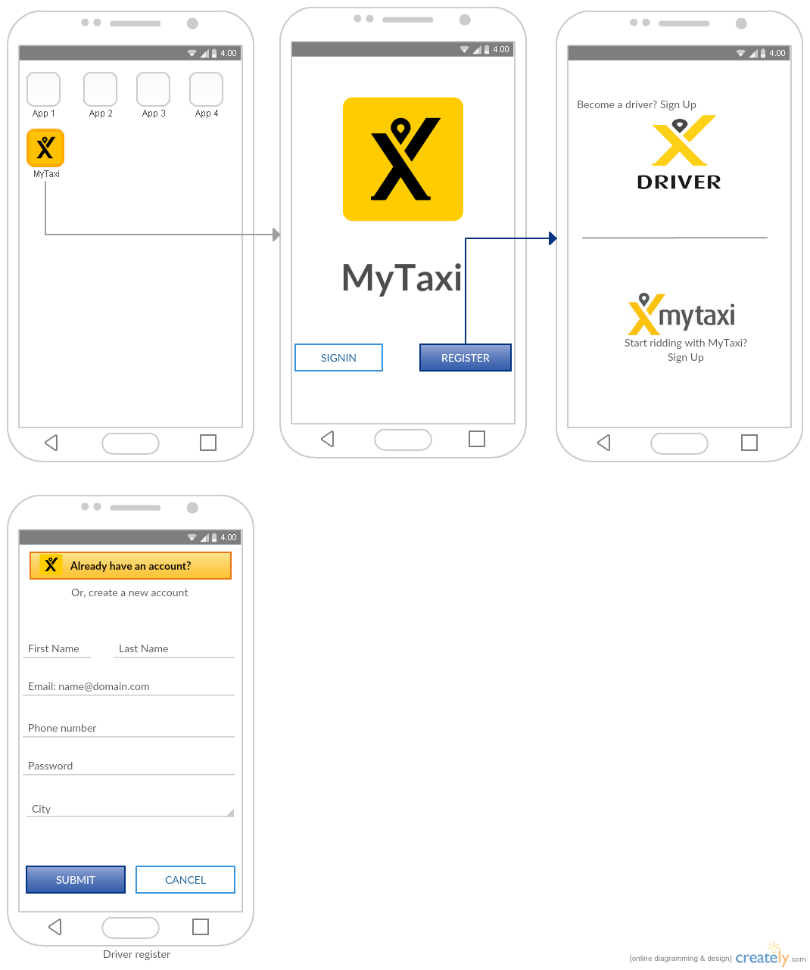

Screen Details

4.1 Screen <Screen SC001 – Start Screen>

Layout
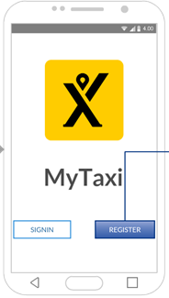

GUI Elements
Note: If there are any discrepancies between screenshot and GUI Elements table, follow the GUI Elements table as the correct one.
Field Name | Description | Control Type | Data Type | Default Value | Required  (Y/N) | Rules
Button “Sign_in” | For user log in to the system | Button
Button “Sign_in” | For user register their information | Button

Screen <Screen SC002 – Choose how to register >

Layout
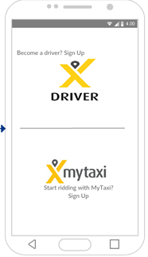

GUI Elements
Note: If there are any discrepancies between screenshot and GUI Elements table, follow the GUI Elements table as the correct one.
Field Name | Description | Control Type | Data Type | Default Value | Required  (Y/N) | Rules
“Become a driver? Sign up” | For driver register their information | Hyperlink
“Start ridding with my taxi? Sign up”” | For passenger register their information | Hyperlink

Screen <Screen SC003 – Driver Register Screen>

Layout
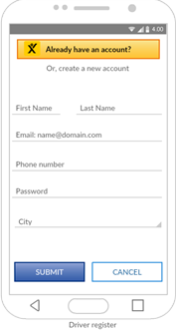

GUI Elements
Note: If there are any discrepancies between screenshot and GUI Elements table, follow the GUI Elements table as the correct one.
Field Name | Description | Control Type | Data Type | Default Value | Required  (Y/N) | Rules
Button “Already have an account” | For driver login if they already have an account | Button |  |  |  | When pressing this button. The system will automatically exit the registration process and redirect the user to the login screen
“First Name” | Insert driver’s first name | Text field | nvarchar |  | Yes | - Wrong data type  - Wrong data range  - Wrong data format  - Required field
“Last Name” | Insert driver’s Last name | Text field | nvarchar |  | yes | - Wrong data type  - Wrong data range  - Wrong data format  - Required field
“Email…” | Insert driver’s email to verify account. System will connect with user by this email | Text field | nvarchar |  | yes | - Wrong data type  - Wrong data range  - Wrong data format  - Required field
“Phone number” | Insert user’s phone number | Text field | int |  | yes | - Wrong data type  - Wrong data range  - Wrong data format  - Required field
“Password” | Insert driver’s password | Text field | nvarchar |  | yes | - Wrong data type  - Wrong data range  - Wrong data format  - Required field
“City” | Insert where drivers living | Text field | Nvarchar |  | no
Button “Submit” | After complete information, Driver press this button to confirm | Button |  |  |  | When click this button, system will run validation. If have any erro information, system will response to user.
Button “Cancel” | Exit register and cancel all information | Button |  |  |  | When click this button, system cancel all information. This information will not save in data.

